Introducing the Electronic RMMR Referral Portal

Dear Doctor,
I have subscribed to Medscope’s Residential Medication Management Review (RMMR) eReferral portal, in order to streamline the Collaborative RMMR referral process. This free portal facilitates an electronic system for requesting and issuing referrals.
Requests for Collaborative RMMR referrals will be sent to you by email (sample email attached) which will contain a link that will grant you access to the secure portal. The portal will list patients under your care that reside in the aged care facility that I will be conducting reviews for.

Accessing the portal
Clicking on the link in the request email will direct you to the portal’s login page.
- Your provider number is your password to the site.
- The unique access code contained in the email link together with your provide number form the secure login.
- The link will expire after 4 failed logins. If this happens, you will need to contact the pharmacist to re-issue the request.

Portal login screen
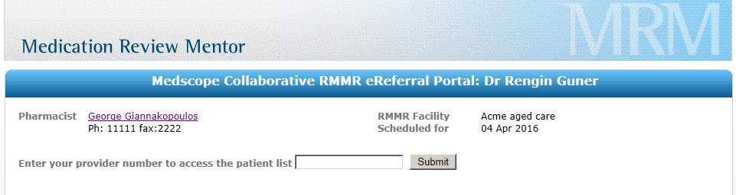

Issuing Referrals
After a successful login, you will be directed to the main Referring screen where the patients under your care will be displayed in one of three sections, Newly admitted residents, Last reviewed more than 24 months ago and patients who have been last reviewed within the last 24 months (and are only eligible for a RMMR if a clinical issue has arisen since their last RMMR). A section will not be displayed if there are no patients that fit into that category.

RMMR portal’s main referring screen
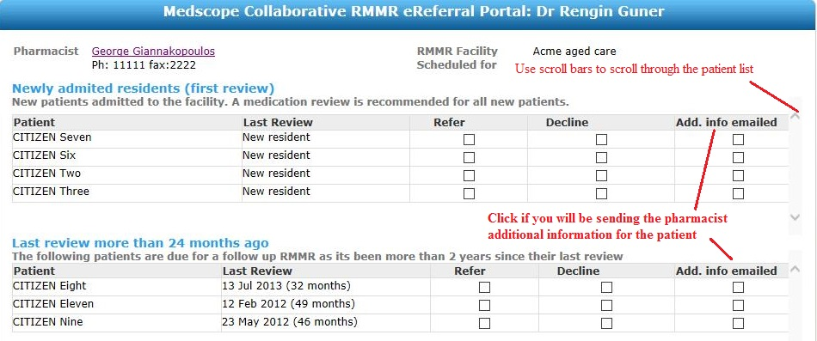
From here you can choose to issue an electronic referral (Refer), Decline or do nothing. You are always able to return to the portal (by clicking on the link in the request email) at a later time to address the remaining.
Patients who had a previous medication review less than 24 months ago
Patients who were last reviewed within 24 months are only eligible for a follow up RMMR if the any of the following apply:
- Discharge from hospital after an unplanned admission in the previous four weeks
- Significant change to medication regimen in the past three months
- Change in medical condition or abilities (including falls, cognition, physical function)
- Prescription of a medicine with a narrow therapeutic index or requiring therapeutic monitoring
- Presentation of symptoms suggestive of an adverse drug reaction
- Sub-therapeutic response to therapy
- Suspected non-compliance or problems with managing medication-related devices
- Risk of, or inability to continue managing own medicines due to changes in dexterity, confusion or impaired
Requesting a follow up RMMR for patients who were last reviewed less than 24 months ago.
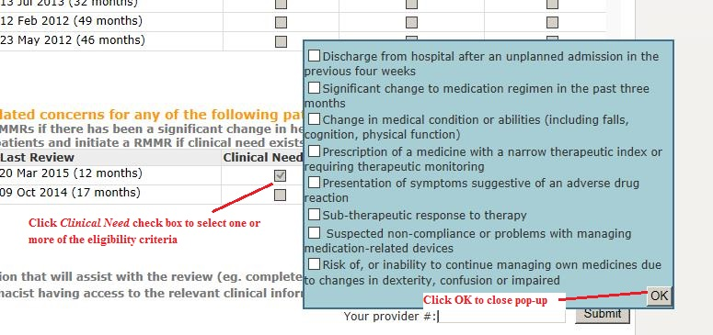

Issuing the electronic Collaborative RMMR Referral
The electronic Collaborative eReferrals for the selected patients are only sent when the Practitioner submits the form (after consent is given and the form is signed with the GP’s provider number). The transaction is recorded and an electronic copy is kept on the portal server for auditing purposes. The electronic Collaborative RMMR referrals are delivered securely to the pharmacist’s subscribed Medscope Medication Review Mentor account.
eReferrals are issued when the Submit button is clicked.
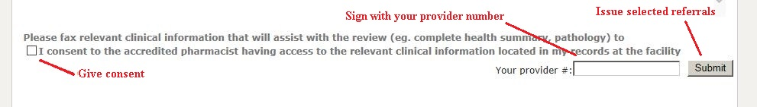

About Medscope
Medscope provides medication review solutions to accredited pharmacists for the purpose of performing Home Medicines Reviews (HMRs) and Residential Medication Management Reviews (RMMRs)

Medscope Contact details:
Web site: www.medscope.com.au
Support: support@medscope.com.au
Enquiries: enquiries@medscope.com.au
Phone: 03 6223 8822

After hours support: 0411206690

Head office: L2, 149A Macquarie street
Hobart, Tasmania, 7000

Attachment: Sample Request for Collaborative RMMR Referrals email
Note
- email shows the accredited pharmacists name, but has been sent from the portal provider’s server – this will always be support@medscope.com.au
- click on the RMMR eReferral portal coded link to access the electronic referral portal. You will need to enter your provider number to enter the portal.


